KAMPALA JUNIOR ACADEMY
HOLIDAY WORK SET TWO TERM I 2020
PRIMARY SIX
INTEGRATED SCIENCE
Time allowed: 2 hours 15 minutes

Name: ______________________________________________________________
School: _____________________________________________________________
FOR EXAMINER’S USE ONLY
Read the following instructions carefully:
- The paper has two sections: A and B
- Section A has 40 questions (40 marks)
FOR EXAMINER’S USE ONLY

Qn. No | MARK | SIGN
1 – 10
11 – 20
21 – 30
31 – 40
41 – 43
44 – 46
47 – 49
50 – 52
53 – 55
TOTAL

- Section B has 15 questions (60 marks)
- Answer ALL questions. All answers to both Sections A
and B must be written in the spaces provided.
- All answers must be written using a blue or black ball
point pen or ink. Diagrams should be drawn in pencil.
- Unnecessary crossing of work may lead to loss of marks.
- Any handwriting that cannot be easily read may lead to
loss of marks.
- Do not fill anything in the boxes indicated;
For Examiner’s use only.

Turn over

SECTION A
1. Name the best soil for growing crops.
_____________________________________________________________________
2. Give one example of a pouched mammal.
_____________________________________________________________________
3. How does painting prevent rusting of metals?
_____________________________________________________________________
4. How is a spur useful to a cock?
_____________________________________________________________________
5. Why is ironing of clothes a good health habit?
_____________________________________________________________________
6. State one danger of deforestation to the environment.
_____________________________________________________________________
7. Why is burning referred to as a chemical change?
_____________________________________________________________________
8. Why is a spider not regarded as an insect?
_____________________________________________________________________
9. What is the gestation period of a ewe?
_____________________________________________________________________
The diagram below shows the structure of an onion. Study it carefully and answer question 10.
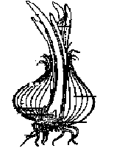

Y

10. Name the type of roots marked Y.
_____________________________________________________________________
11. Give any one property of air.
_____________________________________________________________________
12. Mention one disease of poultry caused by a virus.
_____________________________________________________________________
13. Why do some trees shed off their leaves during a dry season?
_____________________________________________________________________
14. Suggest one reason why bees swarm.
_____________________________________________________________________
15. State any one way through which germs enter our bodies.
_____________________________________________________________________
16. What form of energy does a falling stone have before it reaches the ground?
_____________________________________________________________________
17. How do bees and wasps protect themselves?
_____________________________________________________________________
18. Why is proper disposal of refuse important in a home?
_____________________________________________________________________
19. How is the life cycle of a grasshopper similar to that of a locust?
_____________________________________________________________________
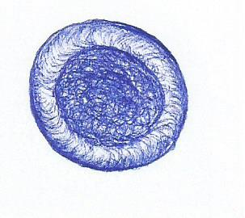
The diagram below shows the structure of a blood cell. Study it and answer question 20.

20. Name the blood cell shown above.
_____________________________________________________________________
21. What is immunity?
_____________________________________________________________________
_____________________________________________________________________
22. How is sound energy produced?
_____________________________________________________________________
_____________________________________________________________________
23. Give one anti-social behaviour.
____________________________________________________________________
24. What causes scabies?
_____________________________________________________________________
25. Why do veins in the body have valves?
_____________________________________________________________________
26. Name the danger of floods in the environment.
_____________________________________________________________________
27. State one disorder of the skeletal system.
_____________________________________________________________________
28. Why do some objects float when placed in water?
_____________________________________________________________________
The diagram below shows an egg. Use it to answer question 29.
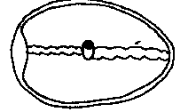
P

29. What does part P develop into after fertilization?
_____________________________________________________________________
30. Which part of air is trapped by the bacteria found in the nodules of legumes?
_____________________________________________________________________
31. Name one method of grazing goats used in rural areas.
_____________________________________________________________________
32. How are fish similar to amphibians in terms of reproduction?
_____________________________________________________________________
_____________________________________________________________________
33. Give one example of a poisonous snake.
_____________________________________________________________________
34. State any one communicable disease common in our homes and communities.
_____________________________________________________________________
35. How do fungi reproduce?
_____________________________________________________________________
_____________________________________________________________________
36. Give one word used to mean the female part of a flower.
_____________________________________________________________________
37. How does malaria spread from an infected person to a healthy one?
_____________________________________________________________________
38. Why do you think a chameleon changes colour?
_____________________________________________________________________
39. Mr. Kadogo catches enough fish for the family to feed on for a week. Suggest one method the family can use to prevent their fish from going bad.
_____________________________________________________________________
40. In the space provided below, draw an illustration to show network venation.

SECTION B
(Questions in this section carry 4 marks each)
41. Study the diagram of a musical instrument and use it to answer questions that follow.
D
B
C
A

(a) To which group of musical instruments does the one above belong?
________________________________________________________________
________________________________________________________________
(b) Which of the strings ABCD will produce sound for:-
(i) high pitch: _____________________________________________________
(ii) low pitch: _____________________________________________________
(c) How does the instrument above produce sound?
________________________________________________________________
42. (a) Name the three types of manure.
(i) ________________________________________________________________
(ii) ________________________________________________________________
(iii) ________________________________________________________________
(b) State one disadvantage of using artificial fertilizers.
________________________________________________________________
43. Human activities are carried out as shown below.
(i) Draining swamps
(ii) Releasing a lot of smoke from factories.
(iii) Crop rotation
(iv) Dumping polythene bags in soil
(a) Which activity will block water and air from entering soil?
________________________________________________________________
- Which activity will cause air pollution?
________________________________________________________________
- Which activity will control pests and diseases?
________________________________________________________________
- Which activity will cause decrease in the amount of rainfall?
________________________________________________________________
44. (a) What is meant by the term “germination”?
________________________________________________________________
________________________________________________________________
(b) Mention any one type of germination.
________________________________________________________________
(c) In the space below, draw a diagram to show the type of germination mentioned in (b) above.

(d) Give one condition necessary for seed germination to take place.
________________________________________________________________
45. Study the table of immunization below and complete it correctly.
 | Disease | Vaccine | Site
(a) | Tuberculosis | BCG | _________________
(b) | Measles | __________________ | Left upper arm
(c) | __________________ | Polio vaccine | __________________

46. (a) Name the smallest stones that are found in the gizzard of a bird.
________________________________________________________________
(b) State what happens to food in the crop of a bird.
________________________________________________________________
(c) Apart from using their beaks, how else do birds protect themselves?
________________________________________________________________
(d) In the space below, draw the foot of a swimming bird.

47. (a) Name the part of air that forms the least percentage.
________________________________________________________________
(b) Give one component of air.
________________________________________________________________
(c) Which property of air enables one to drink soda from a straw?
________________________________________________________________
(d) Why is air called a mixture of gases?
________________________________________________________________
________________________________________________________________

48. Study the diagram of a fish below and use it to answer the questions that follow.
E

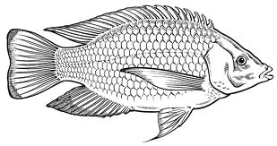
C

A

(a) Name parts labelled with letters A and C.
(i) A. _____________________________________________________________
(ii) C. ______________________________________________________________
(b) State the importance of the feature marked with letter B to the fish.
________________________________________________________________
(c) Give any one characteristic that enables a fish to stay in water.
________________________________________________________________
49. (a) Define the term mammals.
________________________________________________________________
________________________________________________________________
(b) State any two characteristics of mammals.
(i) ________________________________________________________________
(ii) ________________________________________________________________
(c) Mention one egg-laying mammal.
________________________________________________________________
50 Identify any four milk products.
- ________________________________________________________________
- ________________________________________________________________
- ________________________________________________________________
- ________________________________________________________________

51. The diagrams below show two different kinds of eggs. Use them to answer questions that follow.
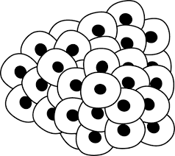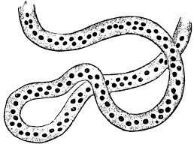
N M
(a) Name the animal that lays eggs shown by letter:
(i) N ______________________________________________________________
(ii) M ______________________________________________________________
(b) State any two differences between the two animals named above.
(i) ________________________________________________________________
________________________________________________________________
(ii) ________________________________________________________________
________________________________________________________________
52. (a) Identify any three activities that can be done by a teacher on a health parade.
(i) ________________________________________________________________
(ii) ________________________________________________________________
(iii) ________________________________________________________________
(b) Give one role played by a school health committee.
________________________________________________________________
53. (a) What is an accident?
________________________________________________________________
________________________________________________________________
(b) Give any two reasons for giving First Aid.
(i) ________________________________________________________________
(ii) ________________________________________________________________
(c) Mention one quality of a good First Aider.
________________________________________________________________

54. Study the diagram below and answer the questions that follow.
A

E
B

(a) Name the part marked with letter B.
________________________________________________________________
(b) State the function of part labelled E.
________________________________________________________________
(c) By what process does food move through the part marked A?
________________________________________________________________
(d) Mention any one disorder of the digestive system.
________________________________________________________________
55. (a) What are weeds?
________________________________________________________________
________________________________________________________________
(b) List two ways of weeding crops.
(i) ________________________________________________________________
(ii) ________________________________________________________________
(c) Suggest any one way a farmer can use weeds.
________________________________________________________________
________________________________________________________________

Good luck

